Project Development Phase
Model Performance Test

Date | 10 February 2025
Team ID | LTVIP2026TMIDS74689
Project Name | Prosperity Prognosticator: Machine Learning for Startup Success Prediction
Maximum Marks

Model Performance Testing:
Project team shall fill the following information in model performance testing template.
S.No. | Parameter | Values | Screenshot
 | Model Summary | -
 | Accuracy | Training Accuracy -  Validation Accuracy - | 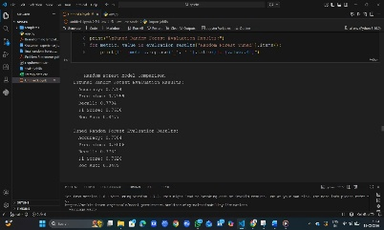
3. | Fine Tunning Result( if Done) | Validation Accuracy - | 